ENTRADA
Key Contact:
Name: Karla MacDonald
Title: Chief Corporate Affairs Officer
Email: kmacdonald@entradatx.com
Phone: (857) 520-9158
Address: One Design Center Pl Suite 17-500, Boston,
MA 02210
Website: http://www.entradatx.com
Nominator: Ryan Farias, SMMA
Banker: Bank of America
Law Firm: Goodwin Proctor
Construction: Siena Construction
Architect: SMMA
PR: Internal by Karla MacDonald
Industry: Biopharmaceuticals
Expansion Location: One Design Center Pl Suite 17-500, Boston, MA 02210

Other Massachusetts Locations:
23,000 +/- (Office and lab combined) space at Smart Labs location at 6 Tide Street in the Boston Seaport.
o 12,600 usable SF
o 4,950 office usable SF
o 7,650 lab usable SF

Project Status: Moved into new corporate offices and laboratories in June 2023. This was the renovation and refurbishment of existing space in the old design center of the Seaport
Financial Investment in Expansion: ~$40 million
SF Expansion: More than ~82K SF
New Jobs: Headcount has increased by 26% with expansion in MA with 41 new jobs.
Demographic diversity of the new jobs created (% based on gender and race) and (% of in-state versus out-of-state hires): Immigration makes an entrepreneur, so the company is very committed to diversity within the workforce and lives these values in the vendors that they use. Over half of the workforce is woman and underrepresented ethnicities and this is very deliberate. The company has been recognized as Boston Globe top places to work with a specific recognition to diversity within the workforce.

Gender: Identify Male: 34%, Identify Female: 66%
Race: Asian: 44%, Hispanic or Latino: 5%, Black or African American: 2%, White: 49%
Location: MA-based: 85%, Not MA-based: 15%

Social impact with community involvement/philanthropic efforts:
Actively partner with organizations across the greater Boston area, providing community and mentorship while challenging the status quo so that we can learn, grow and improve the future for all. Entrada is the inaugural biotech partner of Boston While Black, and is a member of Life Sciences Cares, OUTbio, Latinos in Bio and Women in Bio. They also organize employee participation in toy drives and a backpack donation program for kids. Internal programs to promote EDI education include cultural celebrations, employee social responsibility programs and business resource groups, etc.

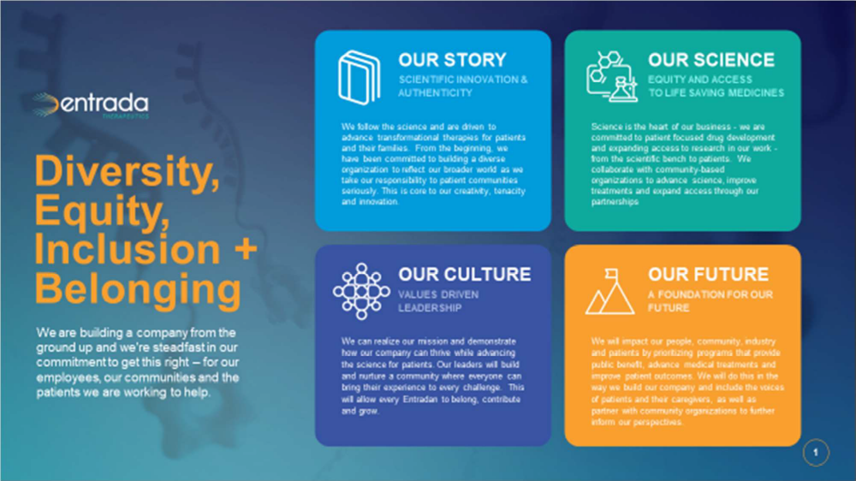

Company Profile:
Entrada mission is to improve Science by establishing a new class of medicines referred to as Endosomal Escape Vehicles (EEV™)-therapeutics. The company has created a culture of bringing your complete self to a collaborative work environment designed to address the challenges of conventional intracellular therapeutics. These medicines have the potential of treating rare neuromuscular diseases including Duchenne muscular dystrophy and through a partnered program with Vertex myotonic dystrophy type 1.

